

Office:+27-31 837 8712 Fax: +27-86 5411 470 Email: skillsdev@malusitraining.net
P.O.Box 12963.Jacobs.Durban.4026 *www.malusitraining.net

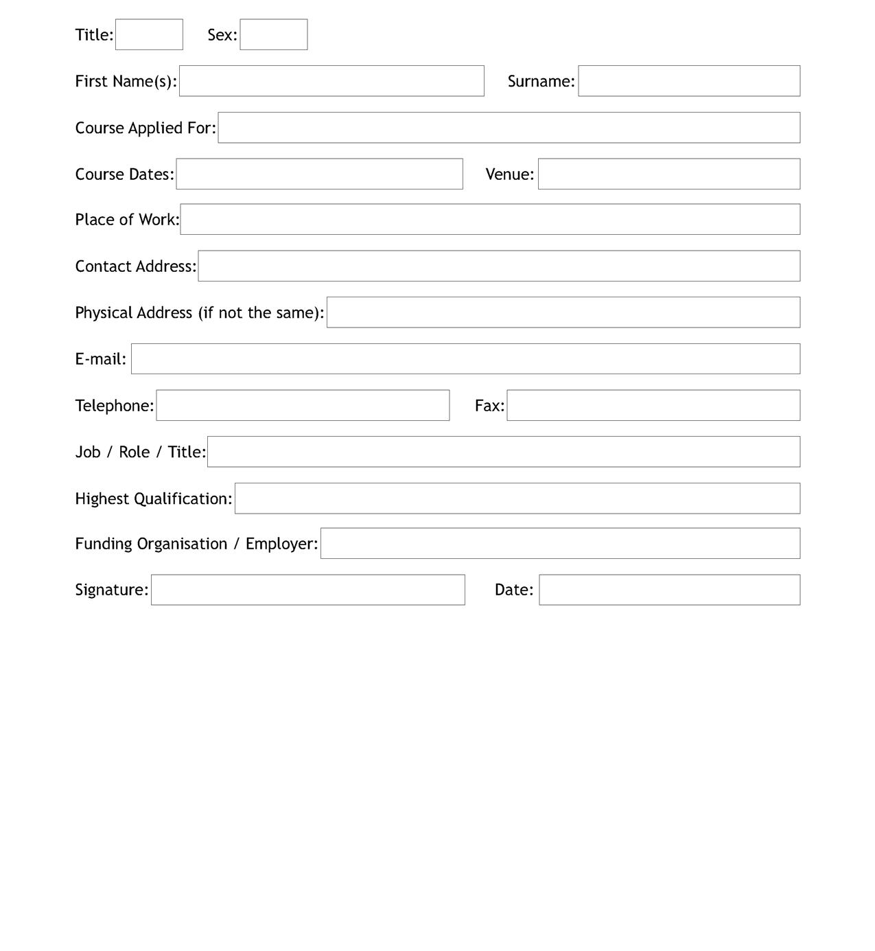
DELEGATE APPLICATION FORM
Please email or fax this form back to our offices once completed and confirmation will be sent to you once application has been processed

